Getting better buy-in from boards

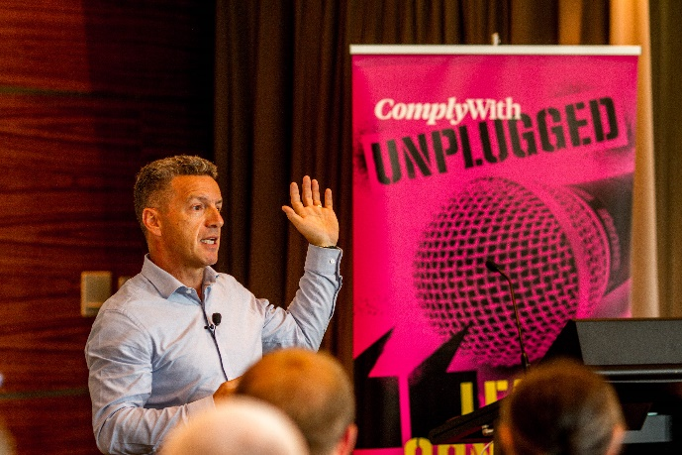

Managers can find it challenging when engaging with a board or committee to get support for compliance and legal risk initiatives. Professional director Michael Ahie offers his advice on getting support from above.

Massey University chancellor Michael Ahie, a professional director and ComplyWith’s board chair, has spent many years observing why some proposals to boards and committees succeed – and why others don’t.

Michael spoke at ComplyWith’s recent Unplugged conference, which gave people the chance to learn, share and connect on ways to better manage their legal risk.

Here are Michael’s top tips on what what works when trying to gain buy-in from directors and from audit and risk committee members.

1. Ask the board what it needs

Rather than allowing time for questions at the end of a presentation, Michael suggests starting by asking directors or committee members if they have any questions about the paper they’re being asked to consider.

“One of the great lessons I’ve learned is for the person presenting to ask the board what it would like to know,” he says.

“Say, ‘You’ve read my paper, so what would make this presentation most useful to you? What questions do you have, and what would you like me to talk you through?’”

2. Be human

If a board member asks you a question you don’t know the answer to, it’s OK not to know.

“One tactic is to say, ‘That is a really good question. Can you give me some more information about what you’d like to know?’ That gives you time to think,” says Michael.

“But the most important thing is to come across as authentic. Be a human being.”

3. Read the room

Find out everything you can about the context of the room you’re walking into – who’s in the room, what the board talked about before you came in, what the mood’s like.

If you can choose when to give your presentation, Michael suggests earlier is always better than later.

4. Keep it short

Don’t assume board members have time to read lots of written information and absorb screeds of data, says Michael.

“Keep your written reports short, crisp and clear. Give the context and say what you want to achieve. Many board papers are read online, so add pictures and links.”

5. Make it emotional

Facts alone are unlikely to sell your proposal, says Michael.

“Understand the make-up of the board. Are they mainly thinking people? Are they mainly feeling people?

“If your paper just hits the ‘think’ stuff, you won’t reach everyone. You have to appeal to people’s hearts, too. Tell them stories and make it real.”

- ComplyWith humanises the law to empower people with knowledge, enable better decision-making and create better operators. Contact us today to find out how we can help keep you out of trouble so that you can achieve your goals.

