Getting your message across using plain English

Writing in plain English helps your readers to find what they need, understand what they find and act on the information. ComplyWith’s Sarah Hine shows why it can be easier than you think to get your message across, increasing your chances of getting better buy-in on compliance.

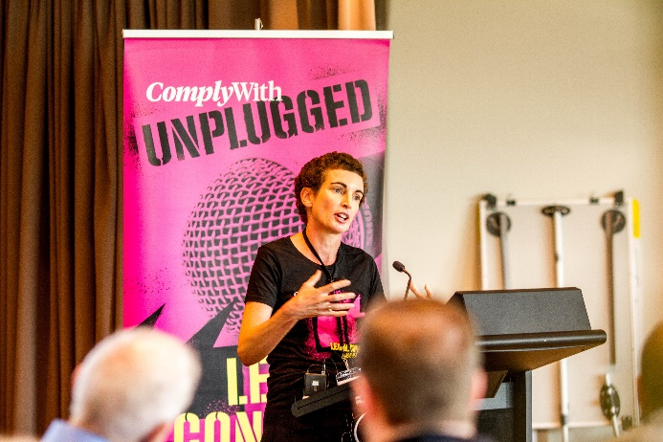

ComplyWith is all about humanising the law, and that includes making legislation easy to understand.

At ComplyWith’s recent Unplugged conference, people had the opportunity to learn, share and connect on ways to better manage their legal risk.

One of the speakers at Unplugged was Sarah Hine, ComplyWith’s senior associate for content development. Sarah revealed key plain English tips to make your writing simpler and more compelling, which can help you improve buy-in on compliance.

Plain English isn’t just about your choice of words, says Sarah. It’s about:
- the big picture
- the language.
- the presentation.

1. The big picture

Start with a purpose statement saying why you’re writing the document and what you want your readers to do with the information.

You’ll need to know who your readers are and what their level of understanding is. They might need background information or explanations of technical terms.

To make the structure of the document logical and helpful, use:
- plenty of headings as signposts for the reader
- headings that summarise the key messages below
- only the information that your reader needs
- tables and graphics to break up the text
- appendices to avoid cluttering up the main body of the document with too much detail.

2. The language

Use:
- short paragraphs, with one idea per paragraph
- sentences with an average of 15-20 words, and one idea per sentence
- specific, familiar words, rather than jargon
- an informal, reader-friendly tone. The more personal you are, the stronger the connection you can make with the reader.

3. The presentation

Use:
- an uncluttered layout
- plenty of white space
- headings that are tied to the text (by having more white space above the heading than below)
- no distractions, such as an inconsistent use of capital letters.

ComplyWith fights for clarity in a world of complexity, legalise, obfuscation and fine print. We want to make legislation simple to understand and easy to act on, and a big part of that is writing in plain English.

Follow the guidelines in this article, says Sarah, and your readers will be able to make the decisions you want them to make with confidence.

- ComplyWith humanises the law to empower people with knowledge, enable better decision-making and create better operators. Contact us today to find out how we can help keep you out of trouble so that you can achieve your goals.

