Using the science of persuasion to improve buy-in

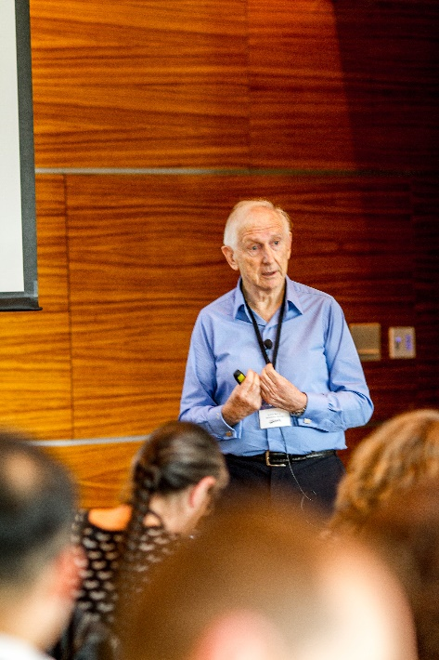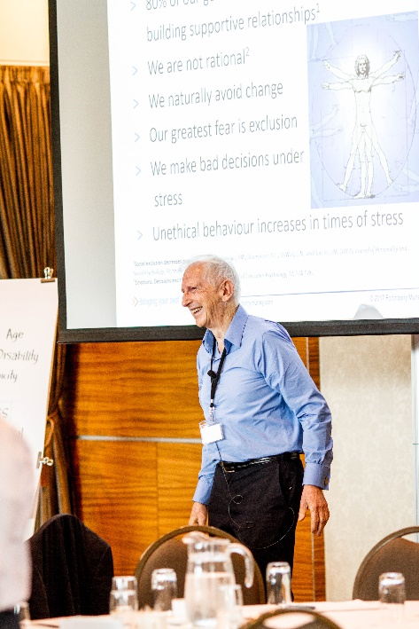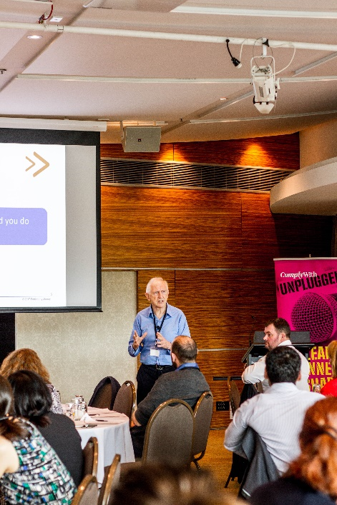

Think the secret to improving compliance is to show people the facts and figures that support your case? Think again! Dr Bob Murray explores new thinking about ways to get better buy-in.

Recent discoveries in human science have revealed surprising new truths about influence and persuasion, according to Dr Bob Murray.

One of Australasia’s leading experts on compliance culture and improving buy-in, Bob was a keynote speaker at ComplyWith’s recent Unplugged conference. The conference gave people an opportunity to learn, share and connect on ways to better manage legal risk and compliance.

Bo’s research shows that getting better buy-in is more about changing hearts than changing minds.

Why reasons and facts do not persuade people

Recent research has found that our brain has no mechanisms to allow us to be persuaded by facts alone, says Bob.

Facts may be relevant, but they are not persuasive. Instead, we are persuaded by the amount of two neurochemicals, oxytocin and dopamine, that reach the decision-making part of the brain.

Persuasion goes through the same neural pathways as relationships. Strengthening the relationship you have with someone will avoid triggering a ‘fight or flight’ response from their sympathetic nervous system, and will stimulate the body’s production of oxytocin and dopamine.

“People make decisions based on relationships and emotions, not facts and reasoning,” says Bob.

“Compliance is about getting people committed to the relationships they have with you. Once you’ve cemented the relationship, you can start persuading them.”

How people think about change

Bob says it’s important for people who want to get better buy-in to understand these key facts about the wiring of the human brain:

- 80% of our genetics and neurobiology are about building supportive relationships.
- we avoid change, unless we’re committed to the relationship we have with the person who wants us to change
- our greatest fear is exclusion
- we make bad decisions under stress
- unethical behaviour increases when we’re stressed. Most bullying, for example, is carried out by people who don’t feel safe.

What’s really going on

In any interaction, argues Bob, the presenting issue is much less important than the relationship you have with the person you’re interacting with. It’s also vital to tackle the underlying issues – the things we’re often afraid to say, such as our fears, hopes and assumptions.

To get better buy-in, you need to make people feel they are safe, they can trust you, they have status and they have the autonomy to make their own decisions.

Dr Bob Murray’s 10 commandments of effective persuasion

1. Smile often
A smile says ‘safety’ and opens the brain to persuasion.

2. Praise judiciously, concretely and often
Praise releases the reward neurochemical dopamine.

3. Make statements that imply an ongoing relationship
We are relationship-forming creatures; it’s where we find our safety.

4. Stress what you have in common
Having things in common increases trust.

5. Don’t ever say the person is wrong
If you do, the brain will see you as the enemy.

6. Take the person to lunch, dinner or, at least, coffee with nibbles
We are more open to being influenced just after eating.

7. Do not criticise the person or the person’s beliefs or assumptions
If you do, you will become the enemy and the person will stop listening.

8. Stay relaxed
Being relaxed makes people feel safer and more open.

9. Be aware of the person’s boundaries and don’t cross them
For example, don’t stand too close.

10. Ask far more often than telling
Facts and reasons don’t persuade; questions that show you’re interested in the person do.

- ComplyWith humanises the law to empower people with knowledge, enable better decision-making and create better operators. Contact us today to find out how we can help keep you out of trouble so that you can achieve your goals.

